First Experiment.

Picture below shows implementation on the lower half of breadboard real estate. The boundary or demarcation between upper and lower is done by dividing the board in two with a pen.

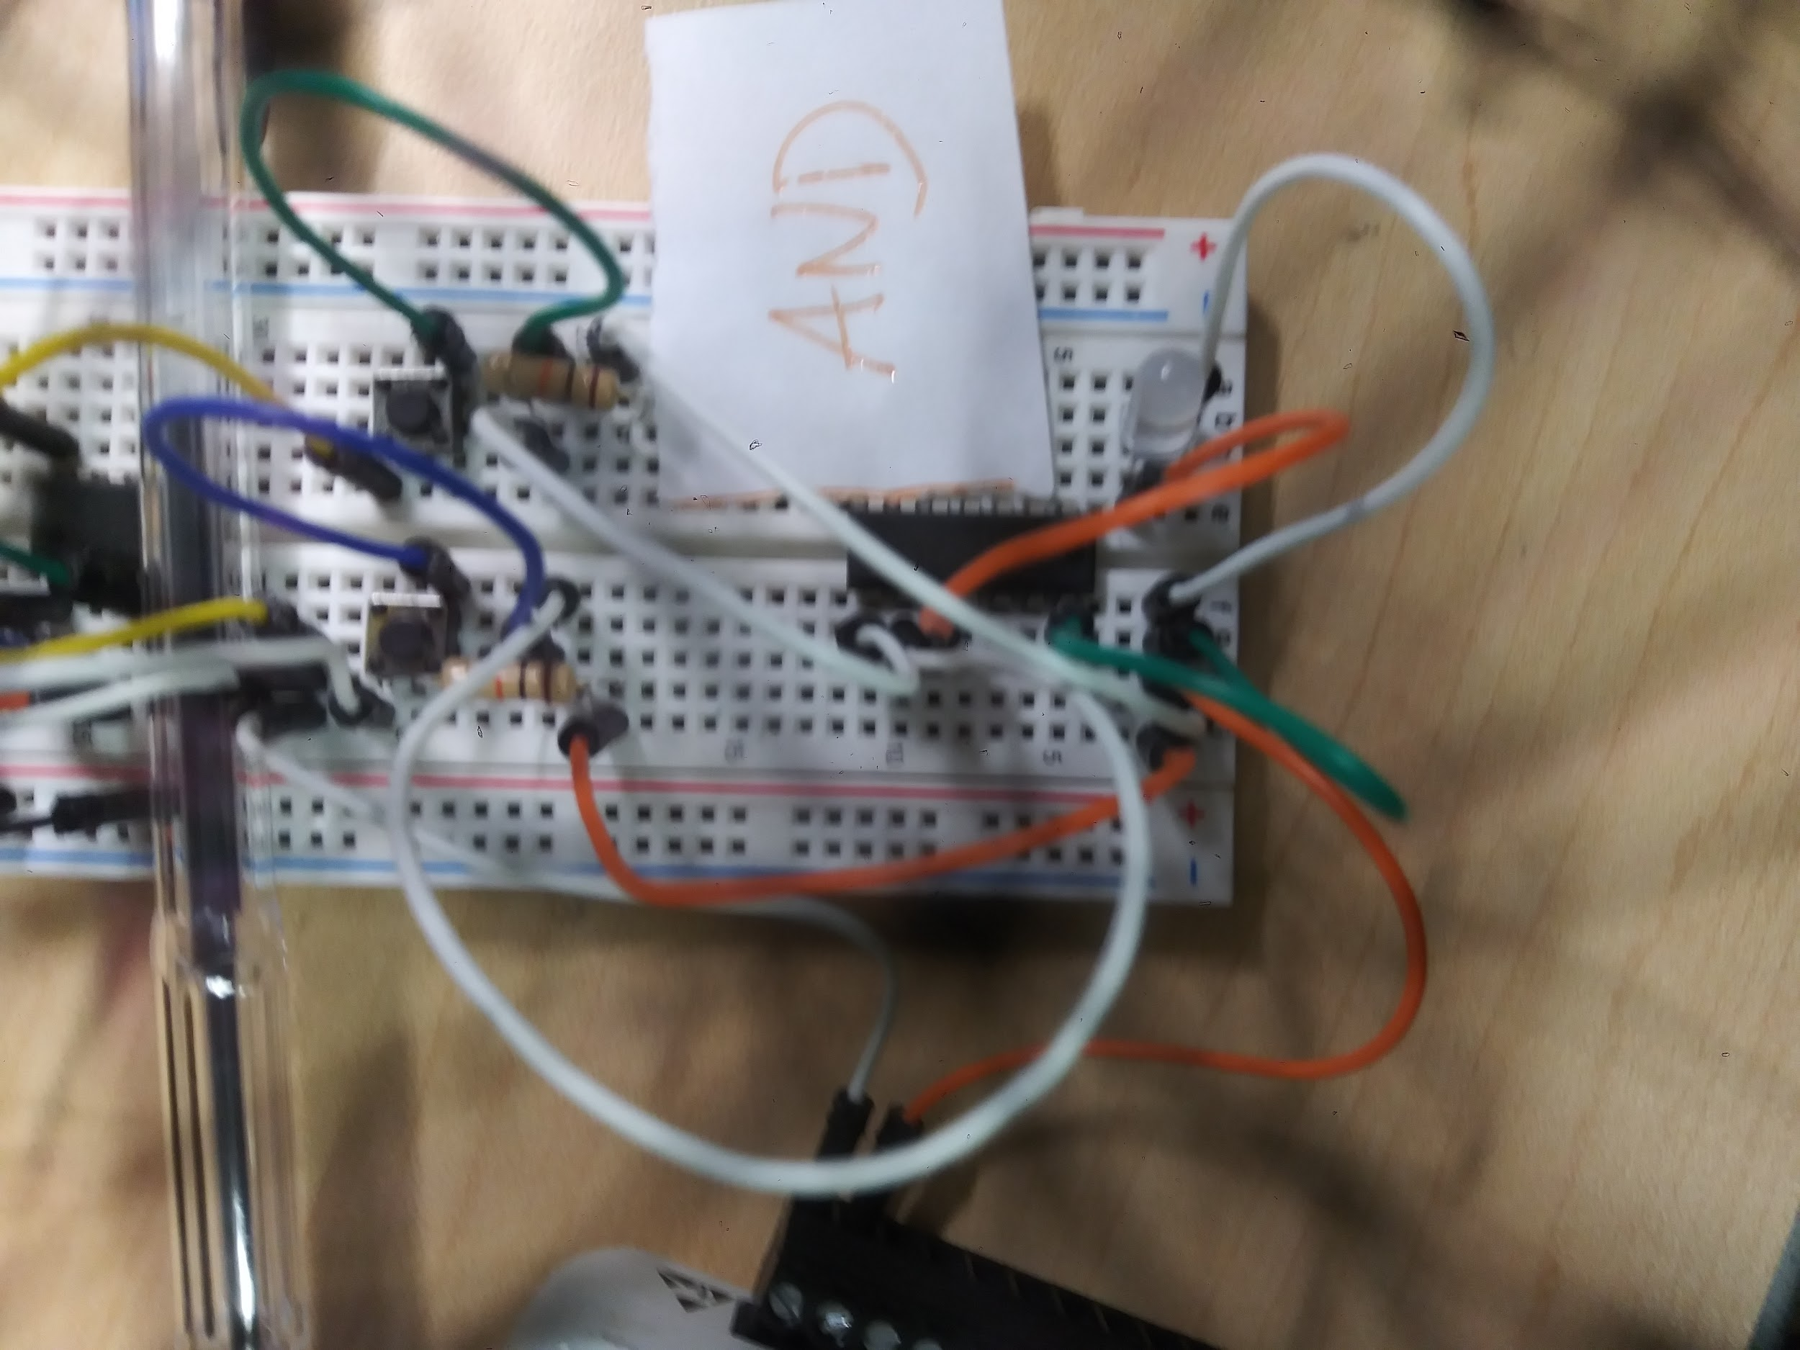

|  |  |  |
| --- | --- | --- |
| A | B | Output |
| 0 | 0 | 0 |
| 0 | 1 | 0 |
| 1 | 0 | 0 |
| 1 | 1 | 1 |

1. The truth table is a table of values (T,F) or cipher (0,1) with combinations of cipher elements and resulting value
2. Not really but if we consider above some threshold value to be on, and below to be off, then it is almost a legitimate truth table. For all practical purposes, it is.
3. Already shown on first page
4. They were the same
5. Two values must be high or on for the output to be on
6. A input is 1
7. B input is 2
8. Output is pin 3
9. I did not put one because my led but typically to pull down.
10. Two gates

Second experiment

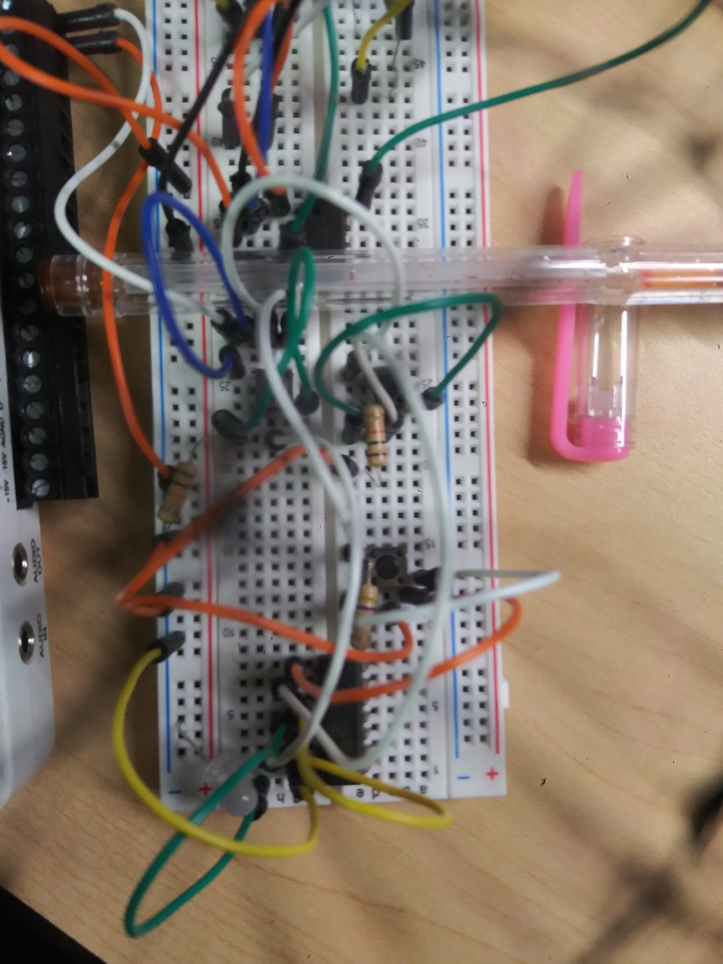

|  |  |  |  |
| --- | --- | --- | --- |
| A | B | C | Output |
| 0 | 0 | 0 | 0 |
| 0 | 0 | 1 | 1 |
| 0 | 1 | 0 | 1 |
| 0 | 1 | 1 | 0 |
| 1 | 0 | 0 | 1 |
| 1 | 0 | 1 | 0 |
| 1 | 1 | 1 | 1 |

1. The truth table is shown above
2. Yes, if we set high to 1 and low to off
3. Same as above
4. Sequential circuits have a clock signal
5. A was 6
6. B was 2
7. C was 1
8. Pin 4 is the output
9. To feed 3 to 5
10. Not sure, pulldown?
11. Four gates
12. To pull down